
GOSFORD ATHLETICS CLUB
JANUARY 2021 NEWSLETTER

The start of 2021 has got off to a busy start for both our Little Athletics and Senior Athletics athletes. Little Athletics started back up again after a nice holiday break whilst the action was coming nearly every weekend in January for our Senior Athletes. We also held our third Gosford Throwers Night on Thursday 21st January which is open to club members plus members of other clubs, results can be found on our website. Here are some of the results from the Athletics NSW meets.

Illawarra High Velocity Meet – 9th January
60m – Ernie Leseberg - 7.27 New Australian Record Mens 45-49yrs
100m – Ernie Leseberg – 11.48
200m – Ernie Leseberg – 23.30

Hunter Pure Performance Track Challenge – 9th January
400m – Tyler Gunn – 47.33
Long Jump – Katie Gunn – 5.91m

Hunter Summer Series – 23rd January
400m - Tyler Gunn – 47.56

NSW Throwers Club – 24th January
Shot Put – Kelly Hunter – 11.86m
Discus – Kelly Hunter – 40.37m
Shot Put – Tom Shannon – 14.67m
Hammer – Tom Shannon – 53.55m

ANSW Mingara Interclub Meet – 30th January
100m – Ella Busch – 15.21
100m – Ruby McTernan – 14.68
100m – Abby McTernan – 14.88
100m – Jay Clarke – 12.31
200m – Jay Clarke – 24.73
400m – Katelyn Wardell – 1:08.91
400m – Lachlan Glasson – 1:13.65
800m – Katelyn Wardell – 2:33.68
800m – Joshua Ireland – 2:17.99
800m – Harry McCluskey – 2:26.61
800m – Lachlan Glasson – 2:43.15
1500m – Joshua Ireland – 4:45.93
1500m – Harry McCluskey – 4:54.59
1500m walk – Caetlin Ashby – 9:49.59
1500m walk – Myles Ashby – 7:44.73
Long Jump – Ruby McTernan – 3.87m
Long Jump – Abby McTernan – 3.59m
Long Jump – Katie Gunn – 5.95m
Discus – Kelly Hunter – 42.66m
Discus – Julia Atilla – 21.62m
Shot Put – Kelly Hunter – 10.47m
Shot Put – Julia Atilla – 9.86m

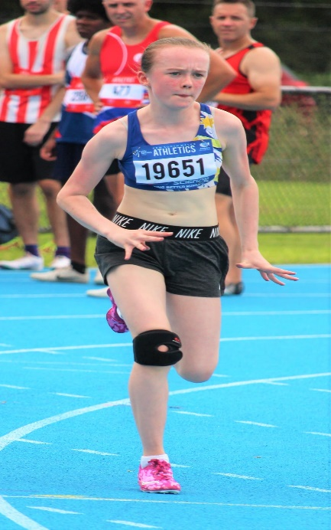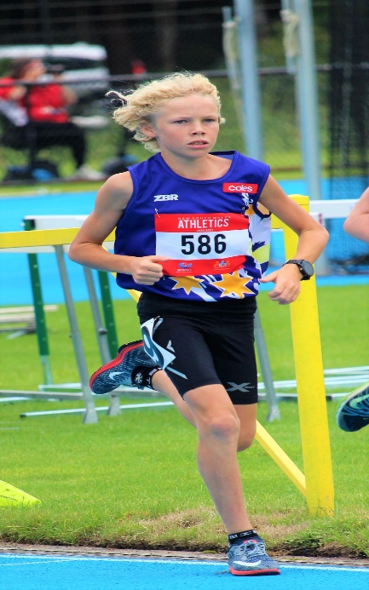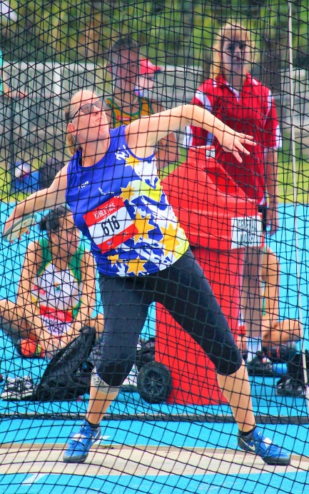

It was great to see some of our Little Athletics members take the step up to Senior Athletics by Dual registering and competing at the Mingara Interclub meet on the 30th January. Dual registration is free for Little Athletics members in the U12s and up age groups. Speak to a committee member about how to go about the process of dual registering or go to the Athletics NSW website and register as a dual member.
Next up for our Senior athletes is the NSW State Masters for athletes over 30years old. It is contested in 5 year age groups and will be held on the 13th-14th February at Campbelltown. Good luck to Kelly, Julia and Ryan.
The NSW Country Championships are on the 26th/27th/28th February at Mingara. This event is held in individual age groups in the juniors U9s up to U18s, then U20s and Opens and in the Masters it’s held in 10 year age categories. This event only allows clubs from NSW Country to enter which Gosford is one of. It should be a great event and we encourage all Senior members, Dual registered athletes and U9s to U11s to compete. Register through the Athletics NSW website or check out our facebook page for the link.
On the weekend of the 6th and 7th February at Maitland, our U9-U12 age groups will be competing at the Little Athletics State Qualifier. Good luck to all 29 of our athletes and they look to qualify for the State Championships to be held in March.
Nominations for the Little Athletics State Championships for the U13-U17 age groups are now open. To nominate for an event please go to the Little Athletics NSW website. Nominations close Sunday 21st February. https://eventdesq.sportstg.com/index.cfm?fuseaction=main&EventDesqID=37185&OrgID=914
Our club multi championship will be held in February for our Little Athletics members. This is a pointscoring event where the further you throw or jump or the faster you run means the more points you score. Score the most points overall for events on the night to be crowned the champion in each age group.
For more information about upcoming events check out the club’s website www.gosfordlittleathletics.org.au
You can also stay up to date by visiting our facebook pages Gosford Little Athletics and Gosford Senior Athletics.
DATES FOR YOUR DIARY
Event | Date | Entries Close
NSW State Masters Championships | 13th-14th February (Campbelltown) | Close 3rd February 10am
NSW Country Championships | 26th-27th-28th February (Mingara) | Close 18th February 9:00am
NSW Opens & U23 Championships | 5th-7th March (SOPAC) | TBA
NSW U14-U20 Championships | 12th-14th March (SOPAC) | TBA
NSW State Little Athletics Championships U9-U12 | 20th-21st March (SOPAC) | Upon qualification from State Qualifiers
NSW State Little Athletics Championships U13-U17 | 27th-28th March (SOPAC) | Upon direct qualification online closing 21st February

